Introduction:

Force plate

NIDAQ

Circuit Boards

Load Cell Sensors

Strain Gauge

Circuit design:

INA 125P

Wheatstone Bridge (pin6 and 7)

8 strain gauges for each full wheat stone bridge (4 in compression, 4 in tension)

2 strain gauges in series

Virtual Ground -9V to 9V (Pin 1 and 3)

Amplification settings

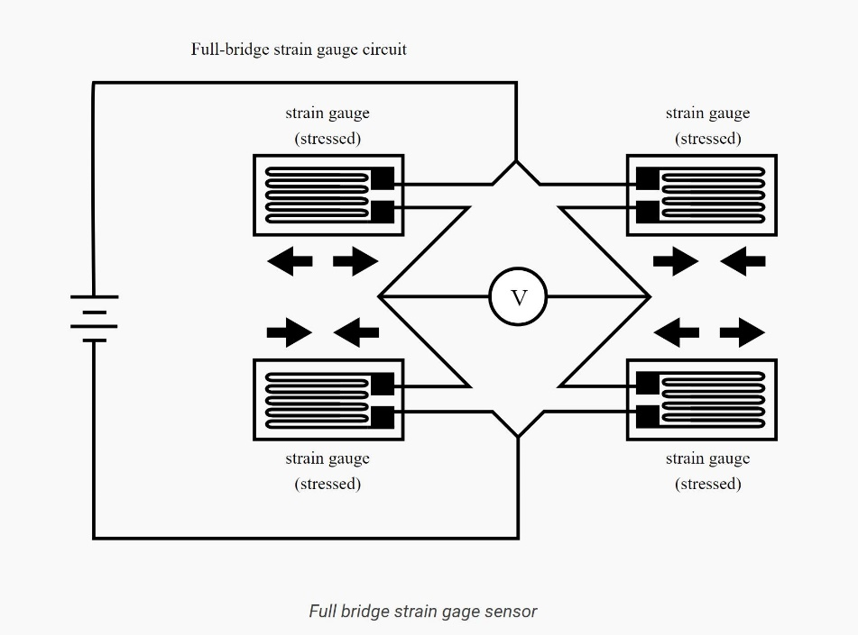

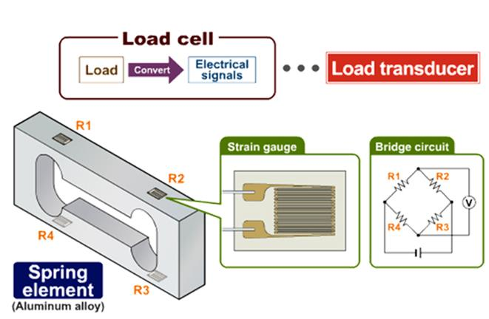

The INA 125 (amplifier) takes the voltage from one side of the wheatstone bridge and compares it to the other. This is important when you want to gather information. The voltage between the two points in the wheatstone bridge has to be zeroed. Turn the variable potentiometer to increase/decrease resistance on one part of the wheatstone bridge. This will help zero out the system. Sometimes you may have to rearrange the wheatstone bridge to zero. If you do this run through short calibrations to make sure everything is still the same.

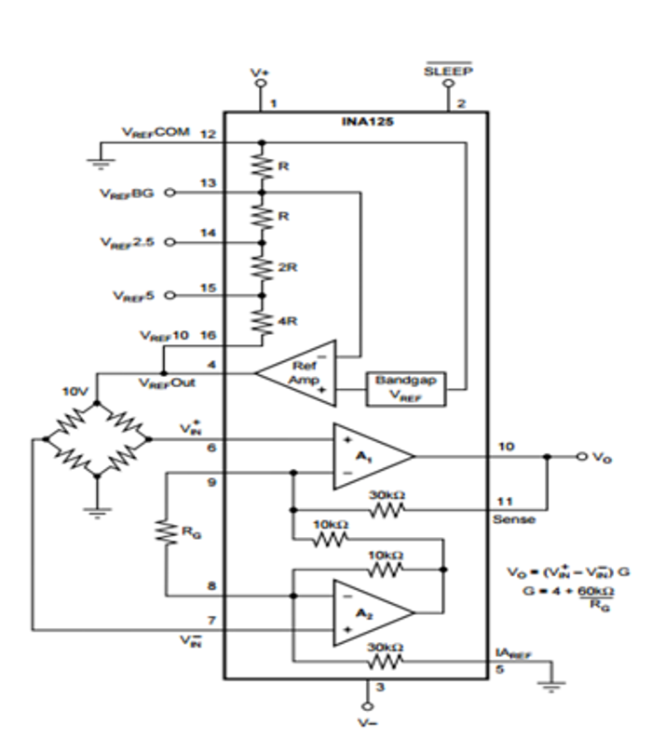

NIDAQ is a data acquisition tool used to gather voltage data from the circuit. Because the circuits are individually grounded, we have to make sure our National instruments inputs are in the proper pin location so each axis has its own ground instead of a sharing a common ground.

Software and toolboxes needed:

Matlab

NIDAQmx tool box

Signal analyzer in matlab (for calibrations)

National instruments

Calibrations in Matlab:

Use the general script to run calibrations but use the Signal analyzer to gather a time stamps of before weight and after weight pictured here. Then run the calibration matlab script to import the time in command window before one of the weight drops and a time stamp during weight (use whole numbers only!). You will input 10 timestamps. After the script will create a 3x5 matrices of the 5 weight drops and the 3 voltage differences between those two timestamps. After running through 3 to 4 different weight classes switch to another directions. Total their a 6 pulling directions you need to gather information from. Im sure there is a way to code for this but for now you will then import all the weight class calibration into an excel file. 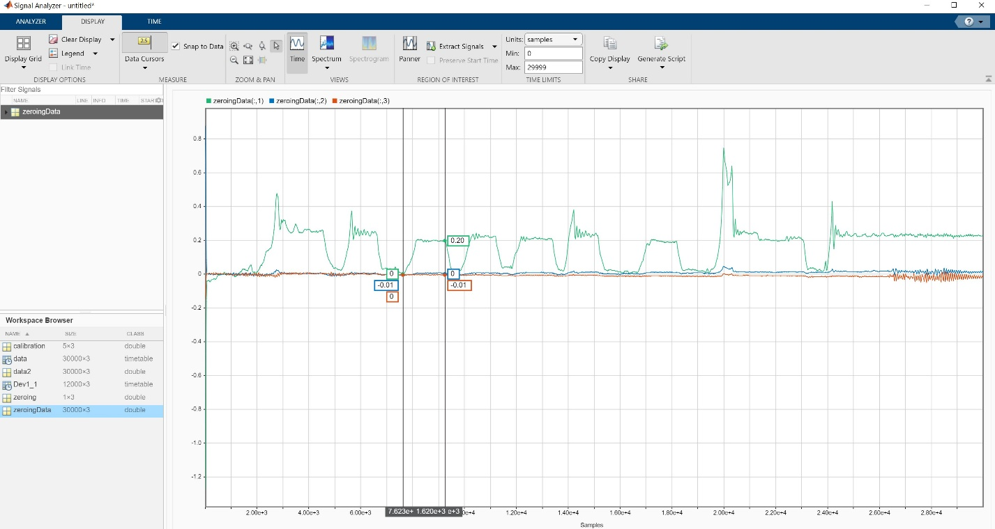

Vertical Foreaft and Lateral voltage change is the first three columns and the last three rows are the known pulling weight in a specific direction. Columns D E and F are known weights in Vertical Horizontal and Lateral respectively.

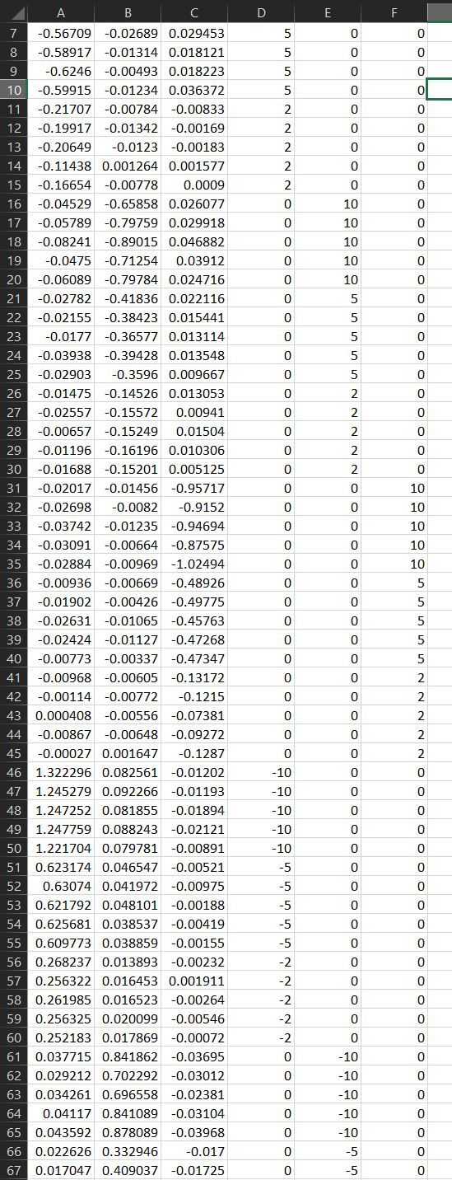

Then in python run the script I supplied to get your calibration matrix. You will eventually multiply this by your force data you collect.